Submission of Linux Assignment 1 from Akshit Agarwal to TuteDude.

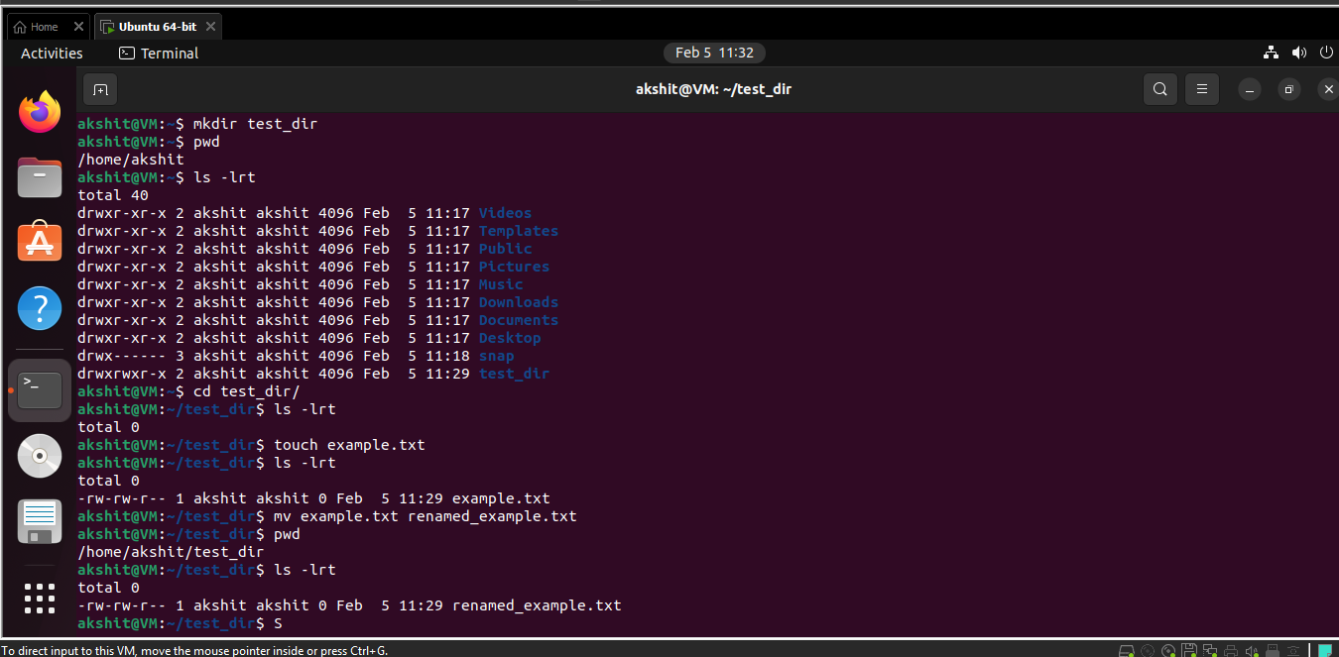
Figure 1Creating and Renaming Files/Directories

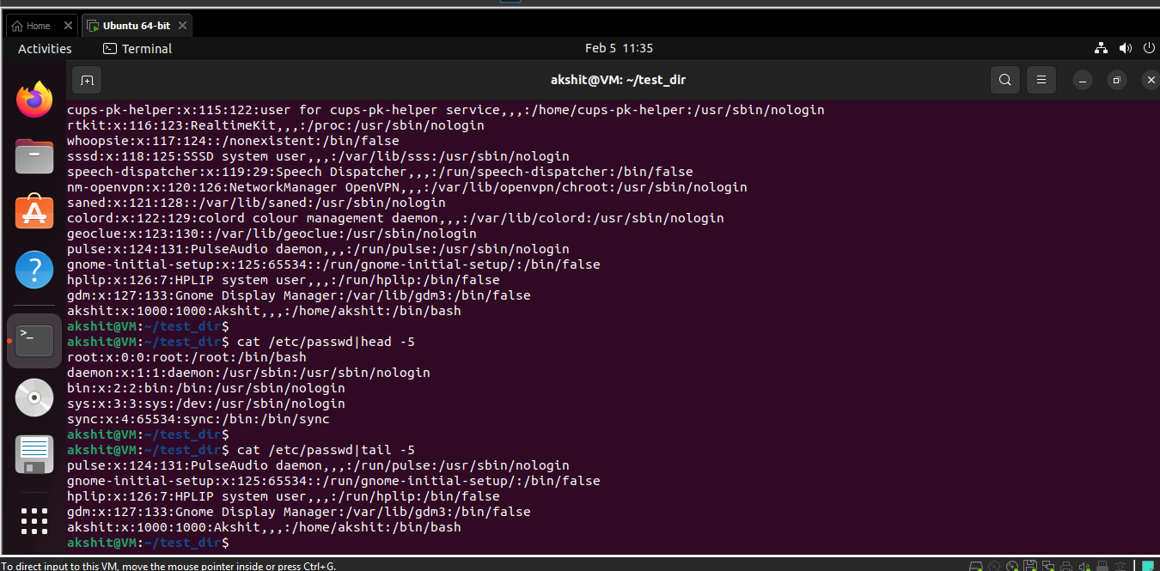
Figure 2Viewing File Contents
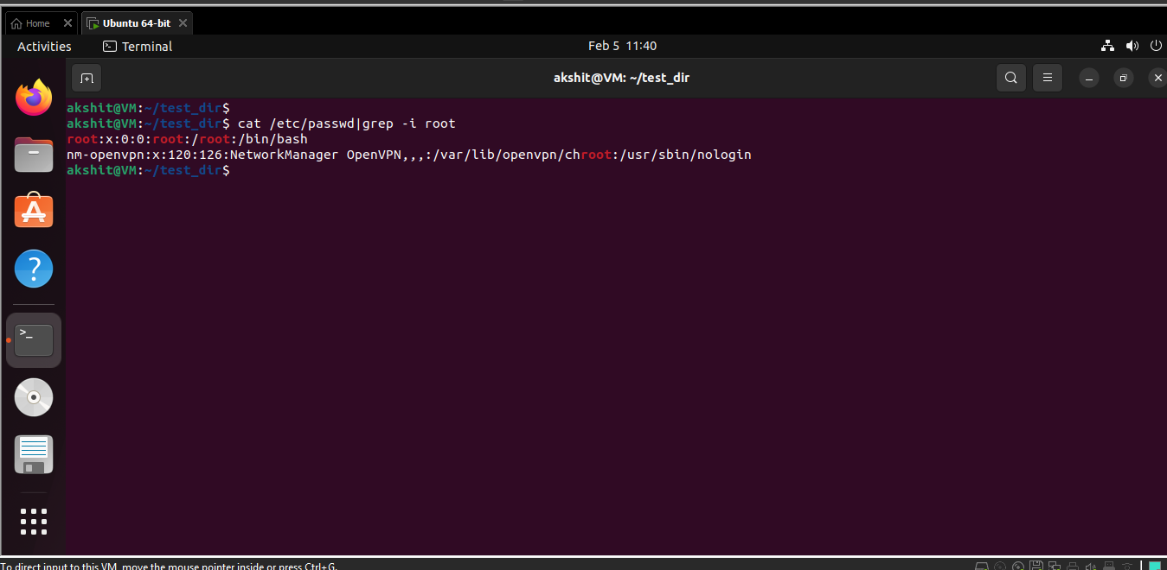
Figure 3: Searching for Patterns

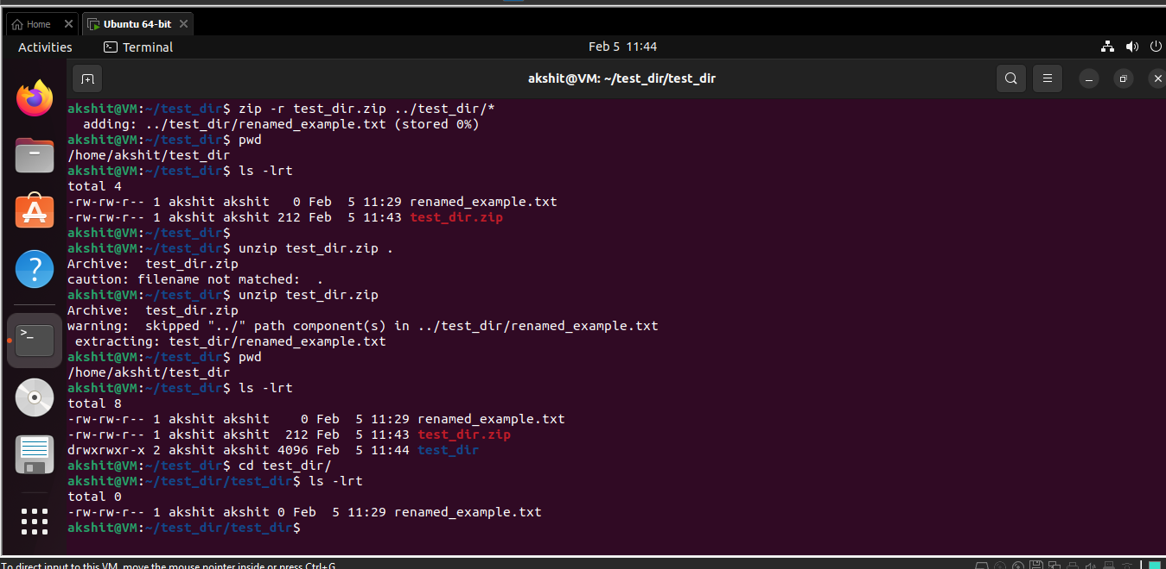
Figure 4: Zipping and Unzipping

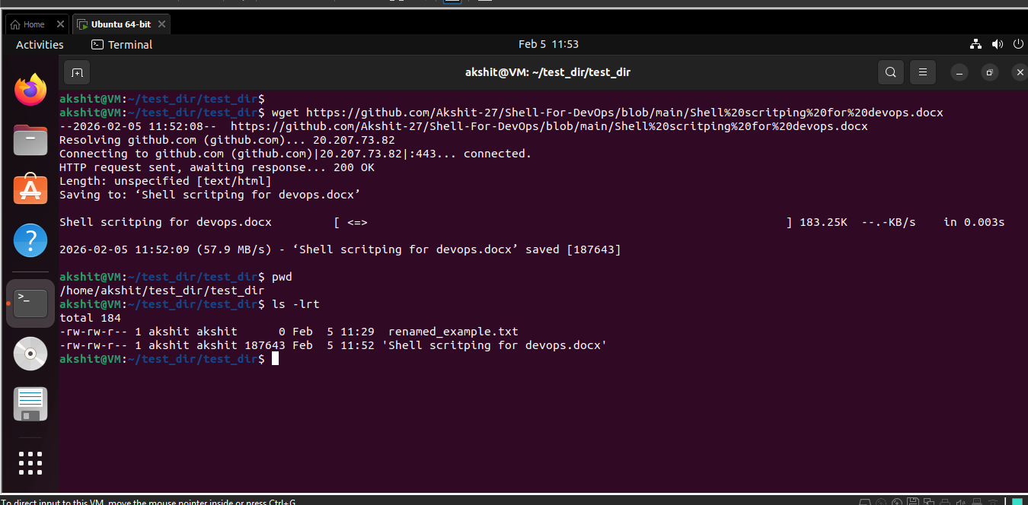
Figure 5 Downloading Files

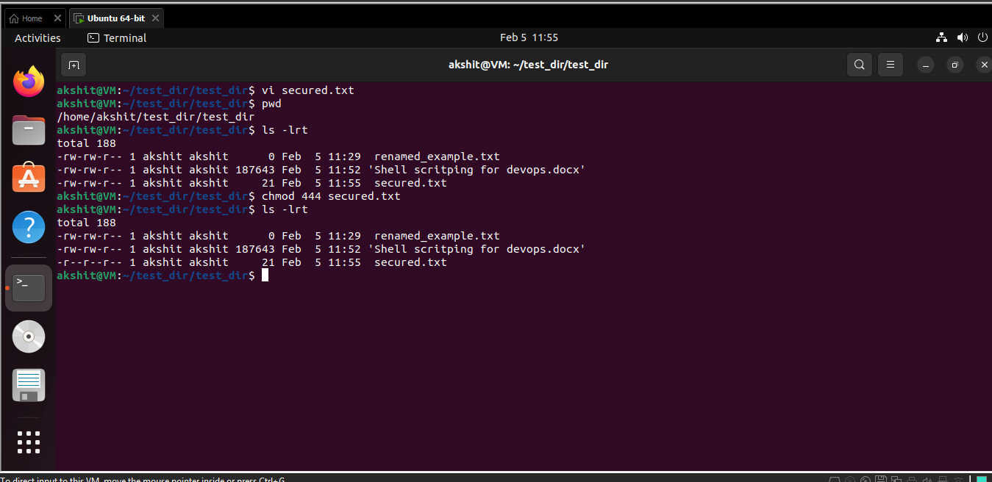
Figure 6 Changing Permissions
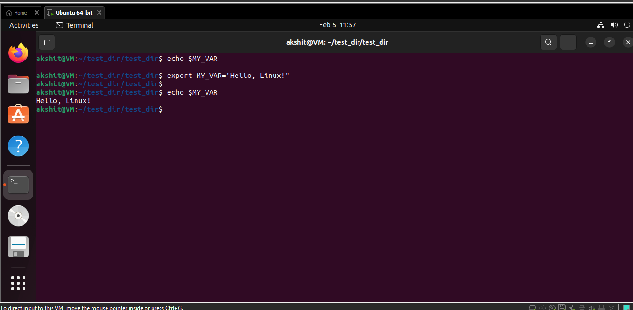
Figure 7 Working with Environment Variables

